

Application for CHAMPVA Benefits  
Form 10-10d

(Debut Date) December 9, 2024 |

Version 2

Revision History

| Date | Version | Description | Author |
| --- | --- | --- | --- |
| 12/9/24 | 1 | Product Debut | Bo Altes |
| 12/10/24 | 2 | Additional screenshots showing file upload confirmation | Bo Altes |

Table of Contents

**Overview 4**

**Signed/in/signed out states 7**

**Introduction 8**

**Step 1: Veteran Information 9**

**Step 2: Identification information 10**

**Step 3: Mailing address 11**

**Step 4: Home address 12**

**Step 5: Contact information 14**

**Step 6: Review and submit 15**

**Error messages 20**

## Overview

VA.gov users who are the spouse or child of a Veteran with disabilities or a Veteran who has died may be able to get health insurance through the Civilian Health and Medical Program of the Department of Veterans Affairs (CHAMPVA). Users can log in or can access and fill out the form without signing in.

The form can be accessed directly through this URL: <https://va.gov/family-and-caregiver-benefits/health-and-disability/champva/apply-form-10-10d/introduction>

It can also be found from the health care home page <https://www.va.gov/health-care/>:

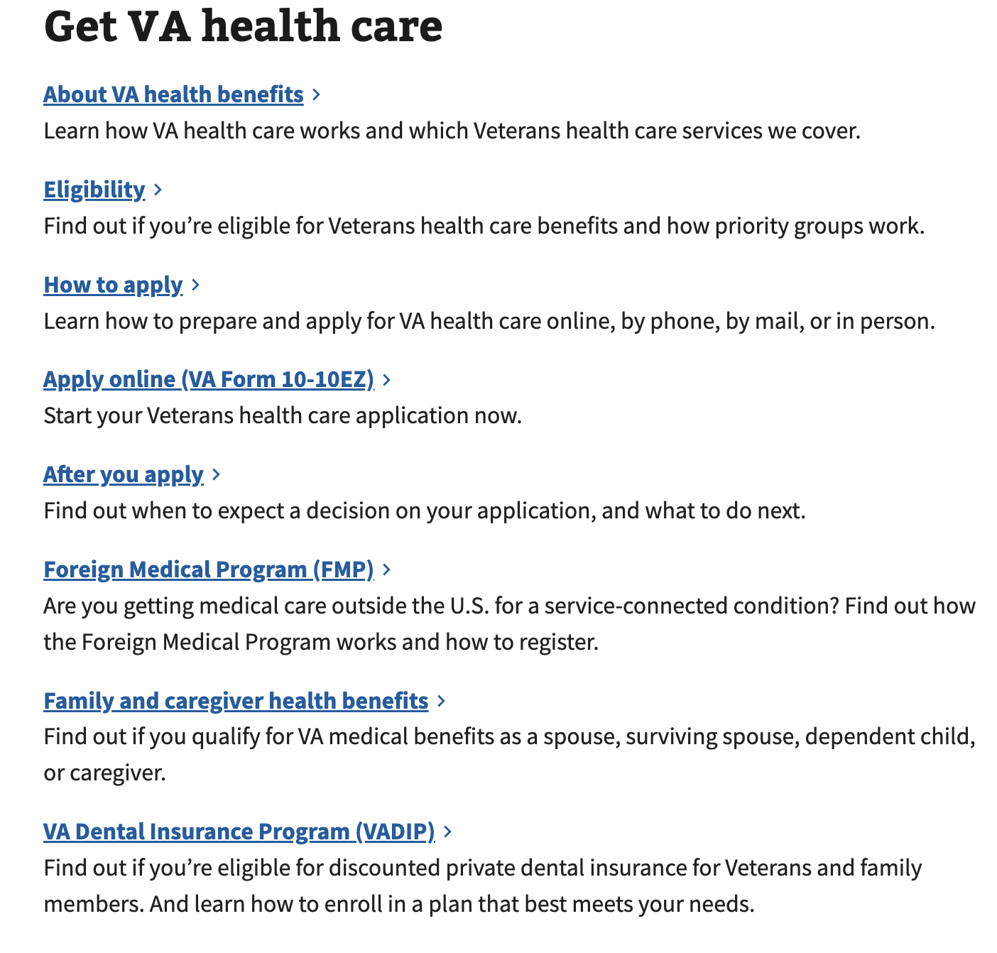

Navigating from the Family and caregiver health benefit link on the health care home page leads to the Health care for spouses, dependents, and family caregivers page.

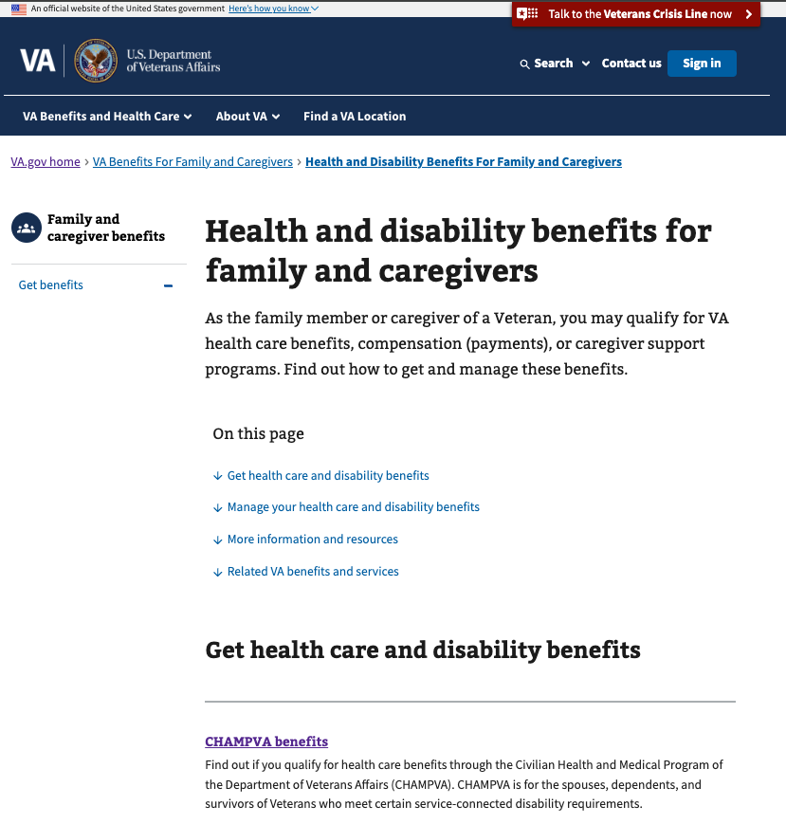

Clicking on the “CHAMPVA benefits” link will take the user to the Introduction page for form 10-10d, which can also be accessed directly at <https://va.gov/family-and-caregiver-benefits/health-and-disability/champva/apply-form-10-10d>

Steps for this form:

1. Signer information
   1. I’m applying for benefits for myself
   2. I’m a Veteran applying for benefits for my spouse or dependents
   3. I’m a representative applying for benefits on behalf of someone else
2. Sponsor information
   1. Identification
   2. Name and date of birth
   3. Sponsor status
3. Applicant information
   1. Additional applicants
   2. Applicant’s address selection
   3. Applicant’s relationship to the sponsor
   4. Medicare and other health insurance status
   5. Supporting document upload
4. Review and submit

## Signed/in/signed out states

* Signed out users can access the registration form through the introduction page. If they follow the unauthorized flow and are not signed into their VA.gov profile, they will not be able to save their progress if they leave the form before submitting.
* If the user signs in, they will be taken to the sign in screen and then able to save their progress when filling out the form.

## Introduction

To start the form, click the call to action on the introduction page:

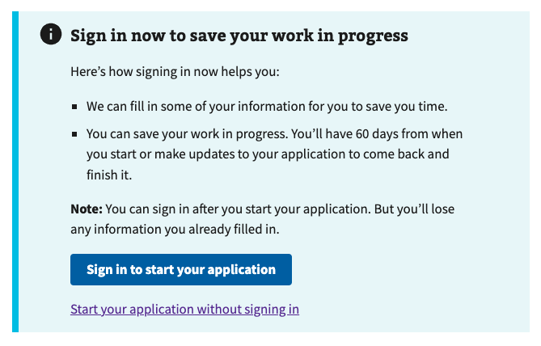

## Step 1: Signer Information

The user is prompted to choose an option that best describes them. The remainder of the form will be modified based on the user’s answer:

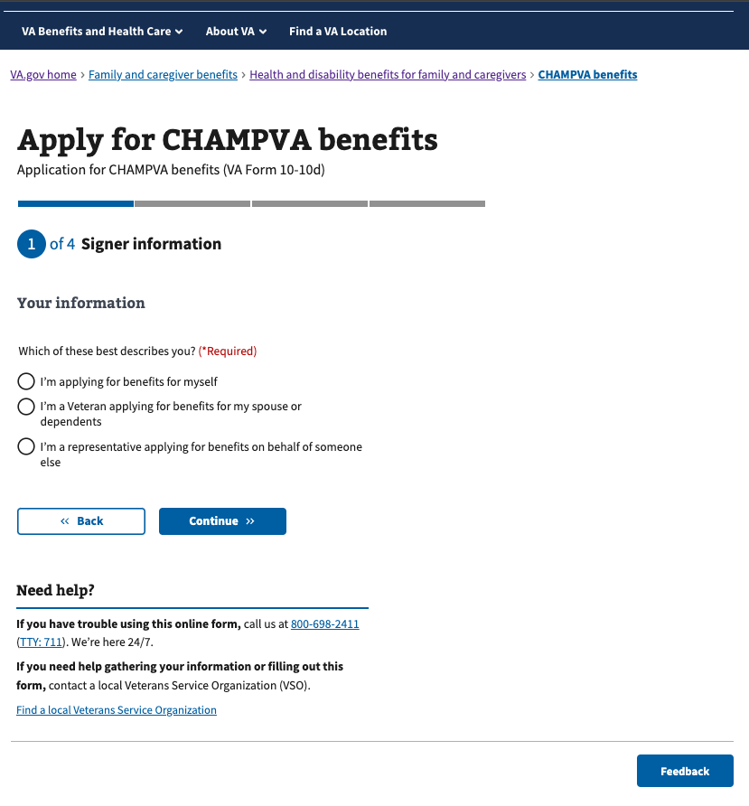

### Option A: I’m applying for benefits for myself

If the user selects “I’m applying for benefits for myself,” they will be asked for additional information about themselves, and that information will be pre-populated later in the form so that they do not have to enter it again as an applicant.

### Option B: I’m a Veteran applying for benefits for my spouse or dependents

If the user selects “I’m a Veteran applying for benefits for my spouse or dependents,” they will be asked for information about themselves as the sponsor, and will then enter information about their dependents, or applicants.

### Option C: I’m a representative applying for benefits on behalf of someone else

If the user selects “I’m a representative applying for benefits on behalf of someone else,” they will be prompted to enter their name, mailing address, phone number, and their relationship to the applicant. Then they will proceed to enter information about the sponsor, as well as the dependents, or applicants.

The user identifying themselves as the sponsor will be required to include their email address as part of entering their information so that the VA can reach them with important information about the application. Email address is optional for the sponsor and applicants if they are not the signer.

The Signer information section is complete once the signer has entered their name, address, phone number, and email address.

## Step 2: Sponsor Information

### Sponsor’s name, date of birth, and identification information

The user must enter information about the sponsor for the application, who is the Veteran associated with the dependents on the application. On the Sponsor information page, the Veteran’s first name, last name, and date of birth are required.

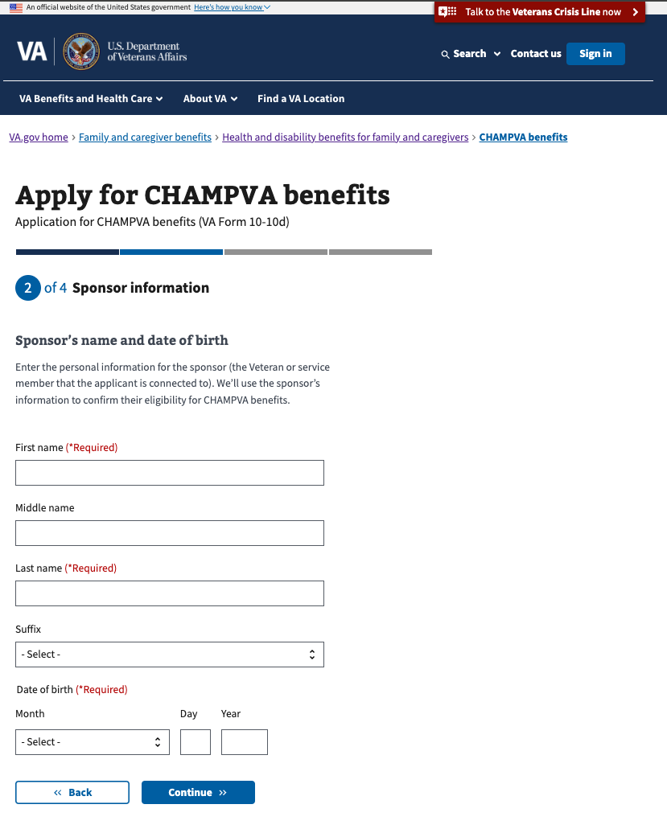

### Sponsor’s identification information

The user must enter the Veteran’s social security number. VA file number is optional.

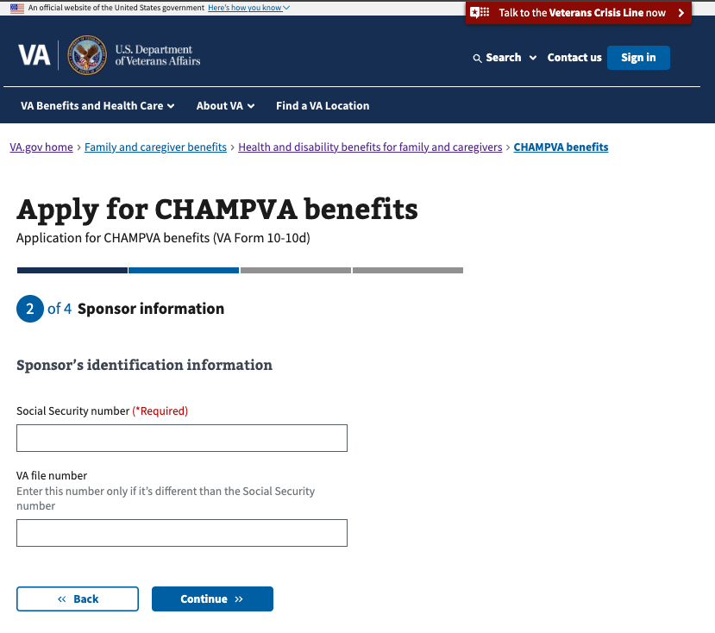

### Sponsor status: has the sponsor died?

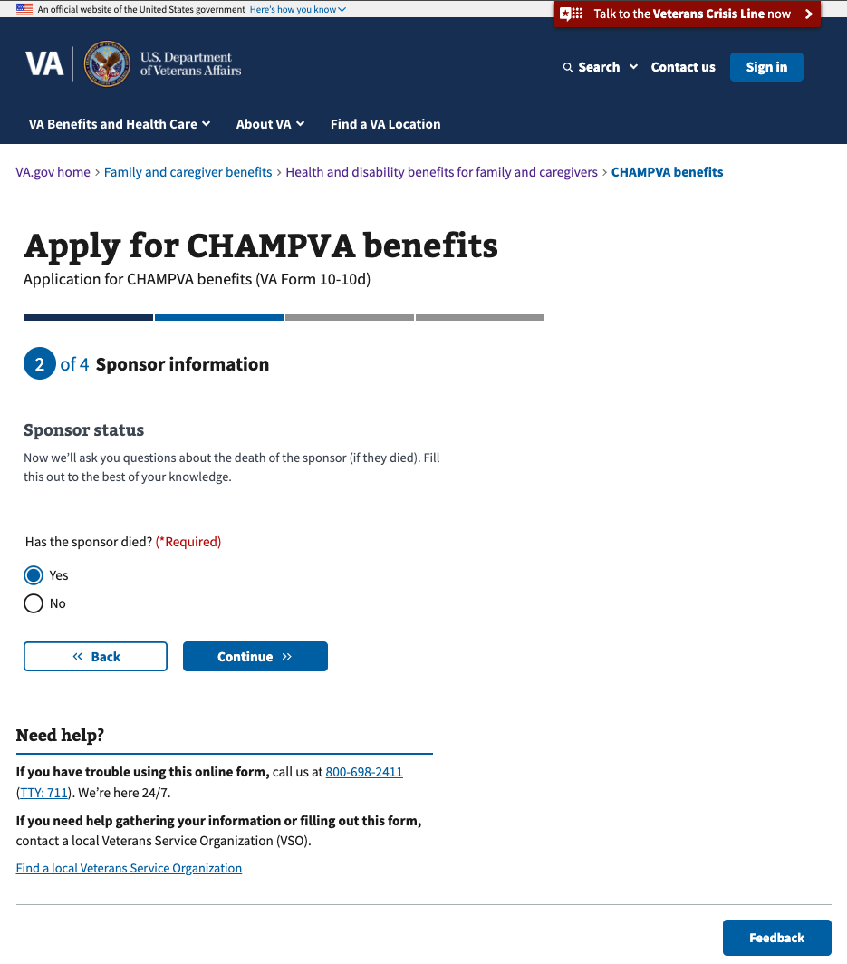

#### Sponsor is deceased

If the user selects Yes under “Has the sponsor died?,” they will be prompted to provide the date of the sponsor’s death, and they will be asked whether the sponsor died during active military service.

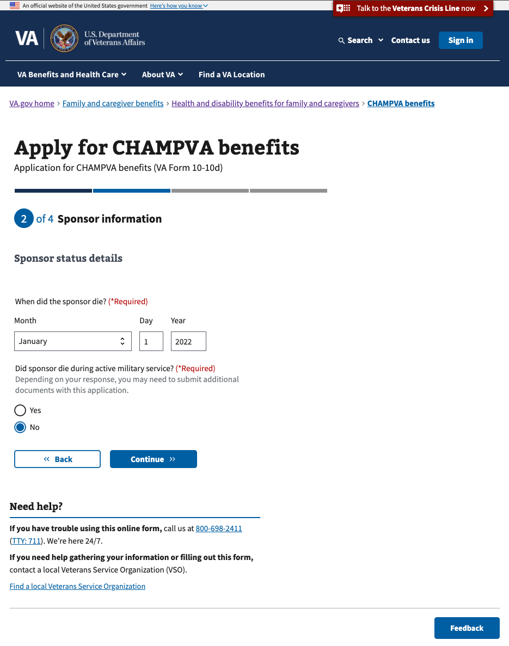

The user will then proceed to the applicant information section.

#### Sponsor is alive

If the user selects No under “Has the sponsor died?,” they will be required to provide the sponsor’s mailing address and phone number.

Each additional person whose information is entered will provide an option to select an address that has already been provided on the form.

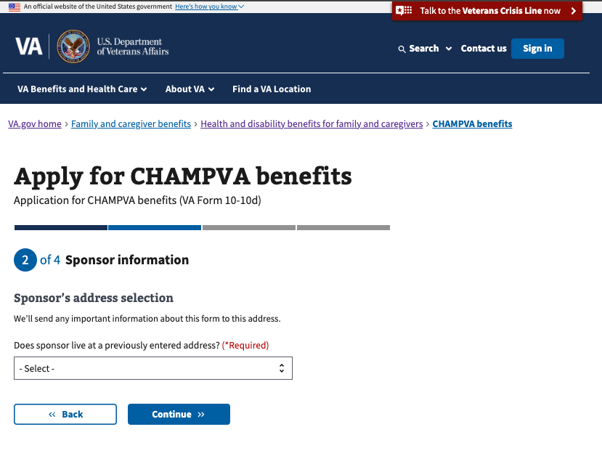

The select dropdown will allow the user to either select an existing address, or enter a new one.

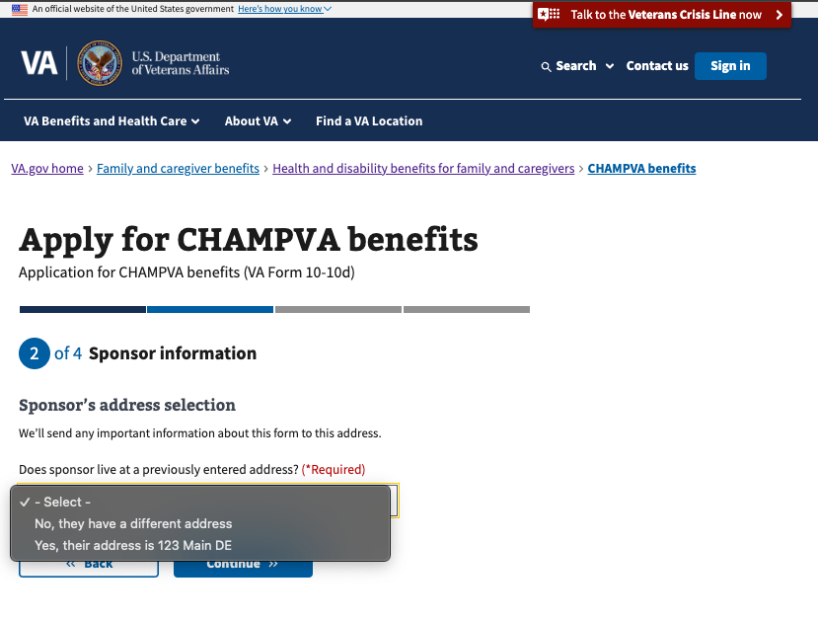

If the user selects an existing address, they will still have a chance to review that address on the next screen and make changes if necessary.

The user will then proceed to the applicant information section.

## Step 3: Applicant Information

The user must enter a name and date of birth for each applicant to be included on the form.

If the user selected “I’m applying for benefits for myself” on the first screen, the first page of the applicant information section will be prepopulated with their information.

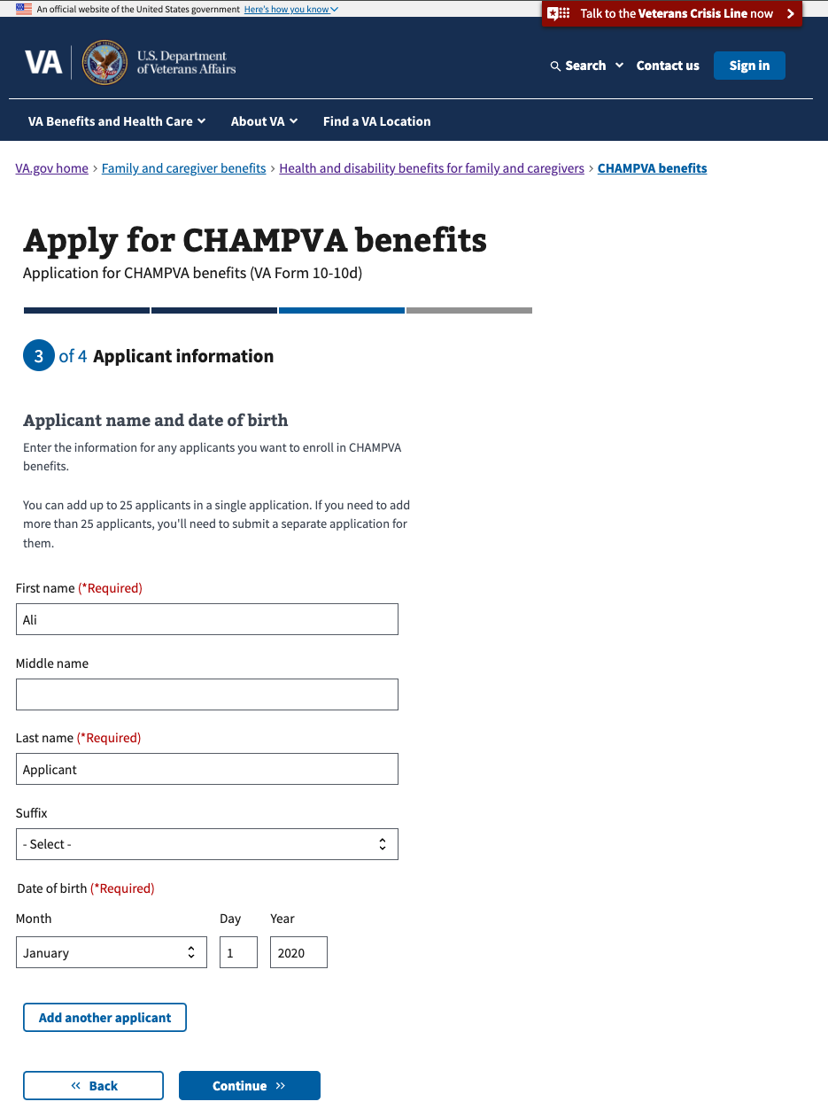

### Additional applicants

To add additional applicants, click the “Add another applicant” button, and enter a name and date of birth for each applicant. The user will be prompted to enter additional information about each applicant that might differ based on their relationship to the sponsor, their age, and their existing health insurance.

The form allows users to add up to 25 applicants.

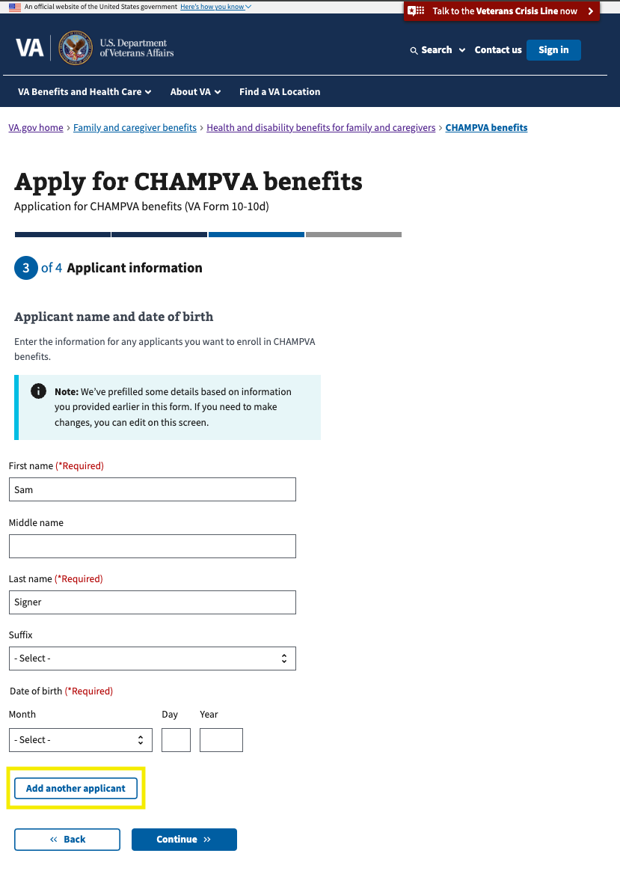

### Applicant’s address selection

The user must enter an address for each applicant. For each applicant, the user has the option of selecting an address that has already been included on the form, or to enter a new address. If the user chooses an existing address, they will be able to verify the complete address on the next screen and either alter the address or continue.

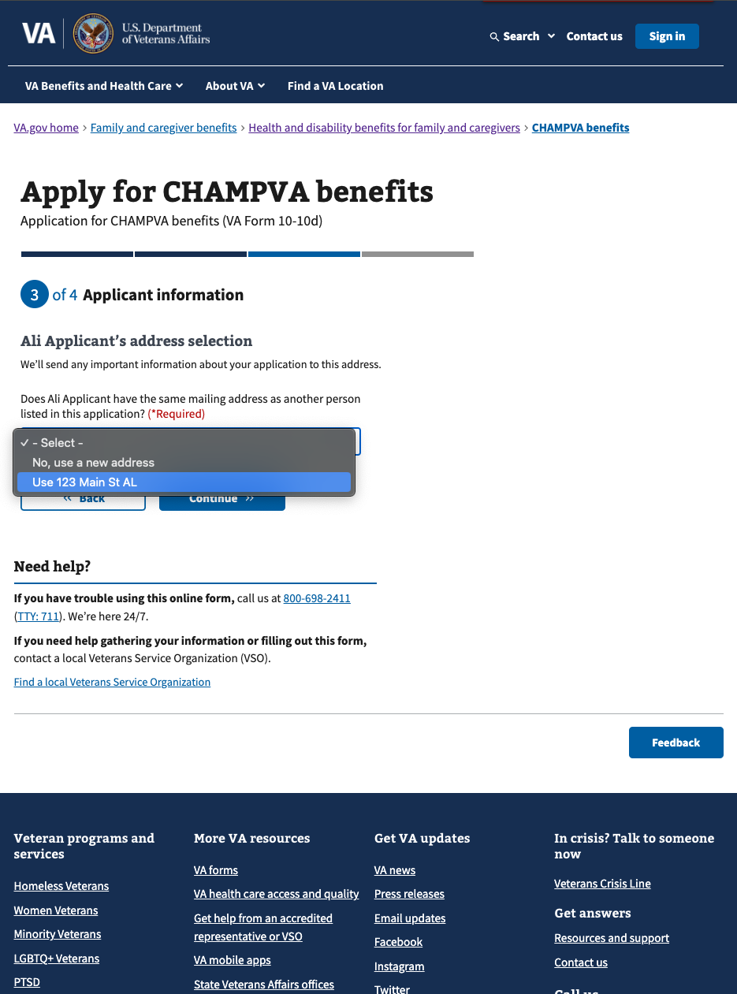

Applicant’s contact information

The user must include a phone number for each applicant. Including an email address is optional for each applicant who is not the signer indicated earlier in the form.

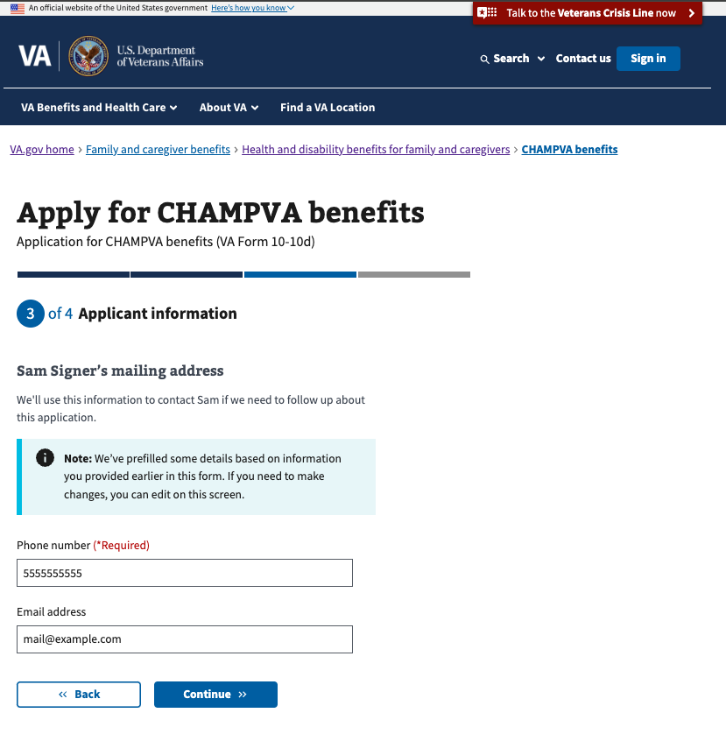

The applicant must select the sex listed at birth for each applicant.

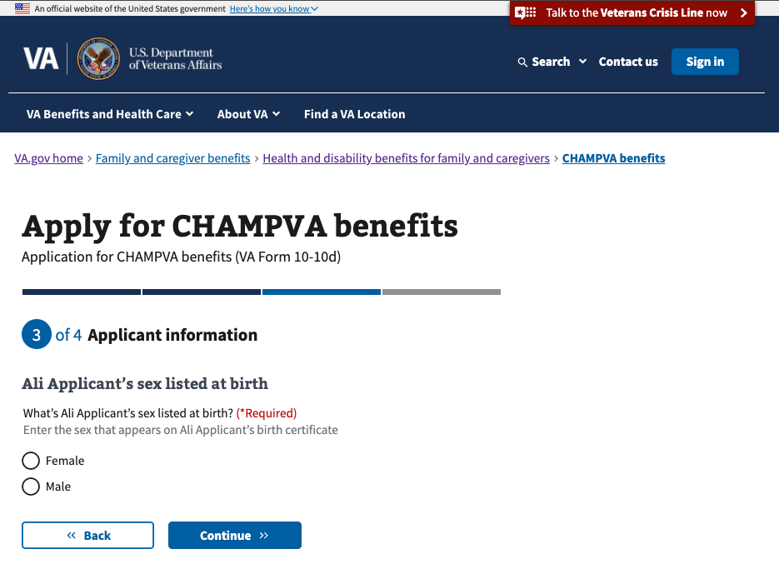

### Applicant’s relationship to the sponsor

The user must select each applicant’s relationship to the sponsor.

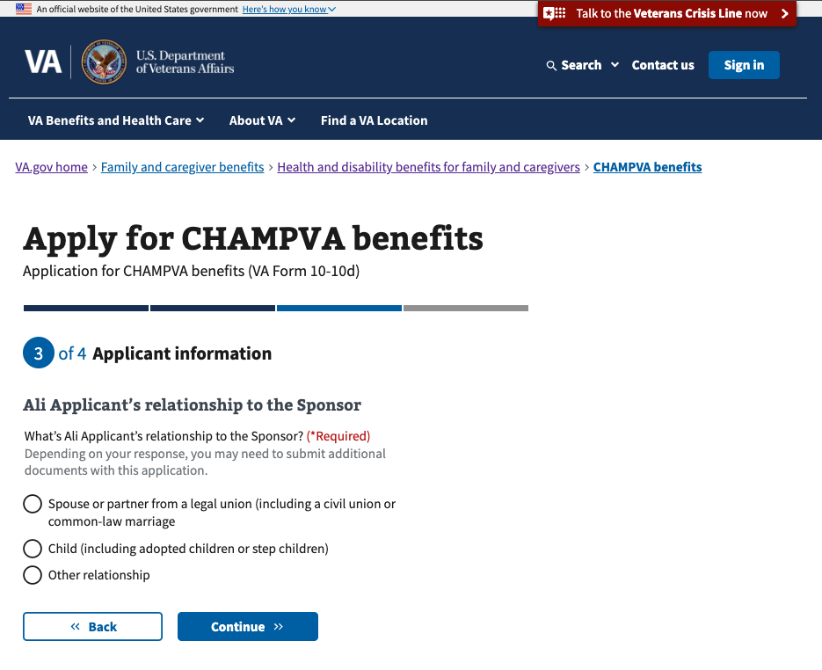

#### Spouse or partner from a legal union (including a civil union or common-law marriage

If the user selects “Spouse or partner from a legal union (including a civil union or common-law marriage,” then the user must enter the date of the applicant’s marriage to the sponsor.

#### Child (including adopted children or step children)

##### Applicant is the Sponsor’s biological child

If the applicant is the sponsor’s biological child, the user will be prompted to upload a birth certificate on the next screen.

##### Applicant is the Sponsor’s step child

If the applicant is the sponsor’s step child, the user will be prompted to upload a birth certificate on the next screen. The user will also be prompted to upload proof of marriage or legal union between the sponsor and the applicant’s parent on the screen that follows.

##### Applicant is the Sponsor’s adopted child

If the applicant is the sponsor’s adopted child, the user will be prompted to upload a birth certificate on the next screen. The user will also be prompted to upload proof of adoption on the screen that follows.

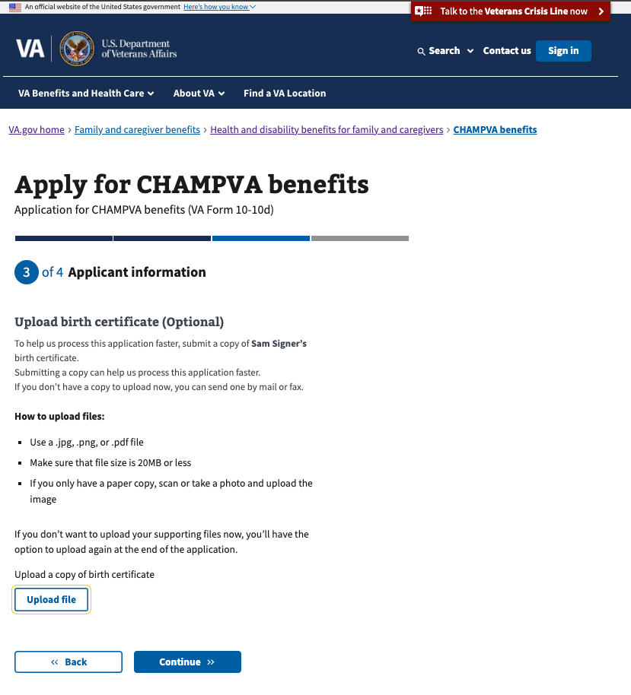

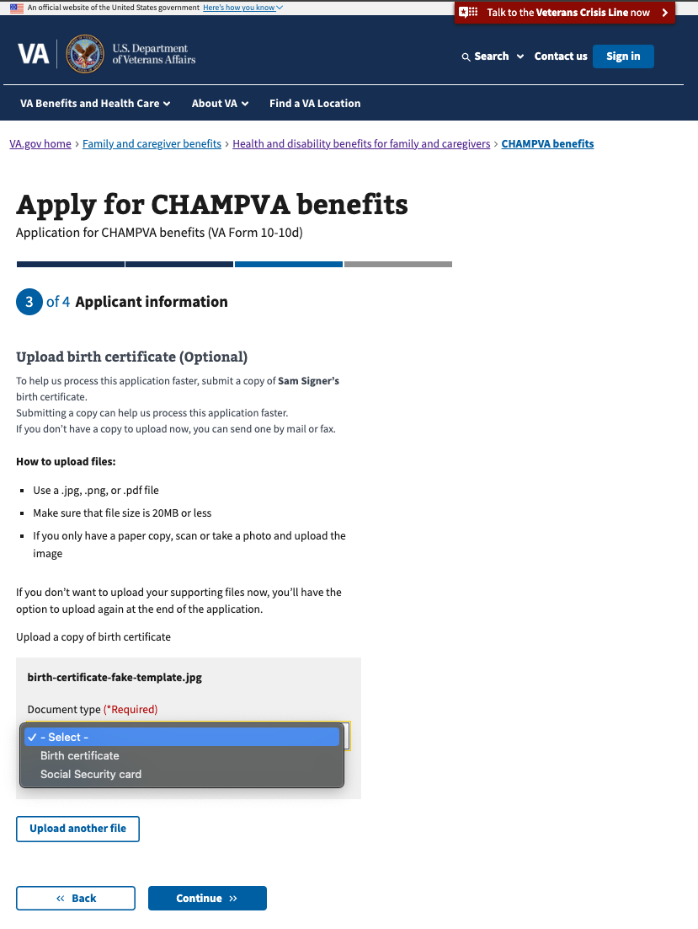

##### Applicant’s status

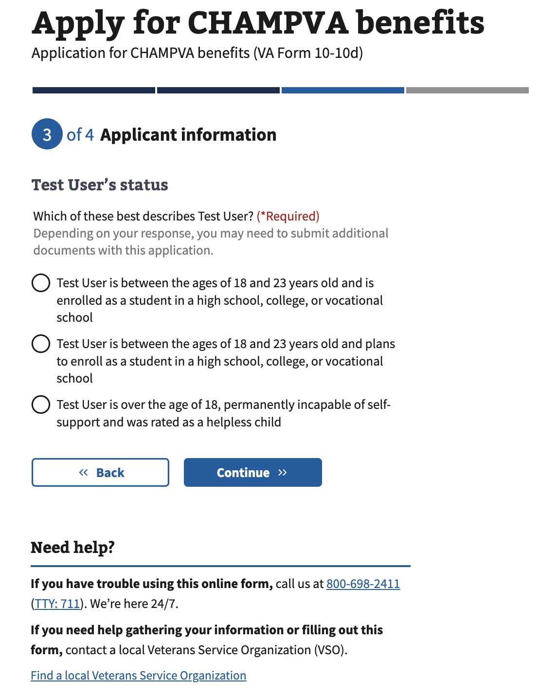

#### Other relationship

If the user selects “Other relationship,” then the user must enter a description of the relationship. The user will then proceed to the next section.

### Medicare and other health insurance status

Medicare Part A and B status

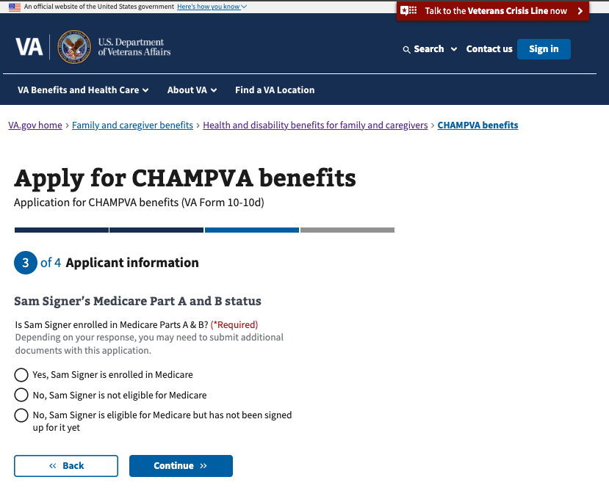

If the user selects Yes, they will be prompted to upload pictures of the front and back of their medicare cards on the next screen, and will be asked if they are enrolled in Medicare part D.  
  
If the user selects either “No” option, they will proceed to Other Health Insurance certification.

Medicare Part D status

If the user indicated that they are enrolled in Medicare parts A and B, they will also be asked if they are enrolled in part D, and prompted to upload their card if they answer yes.

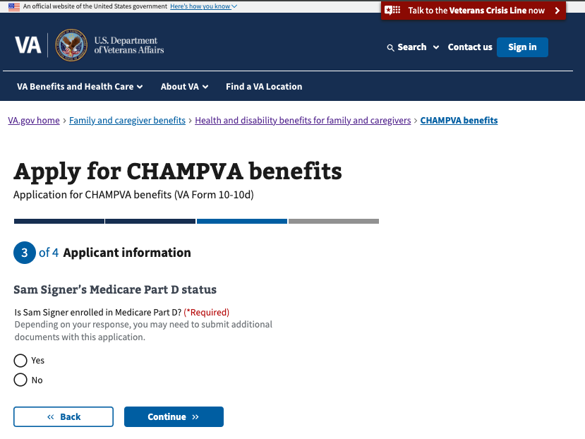

Upload Medicare cards

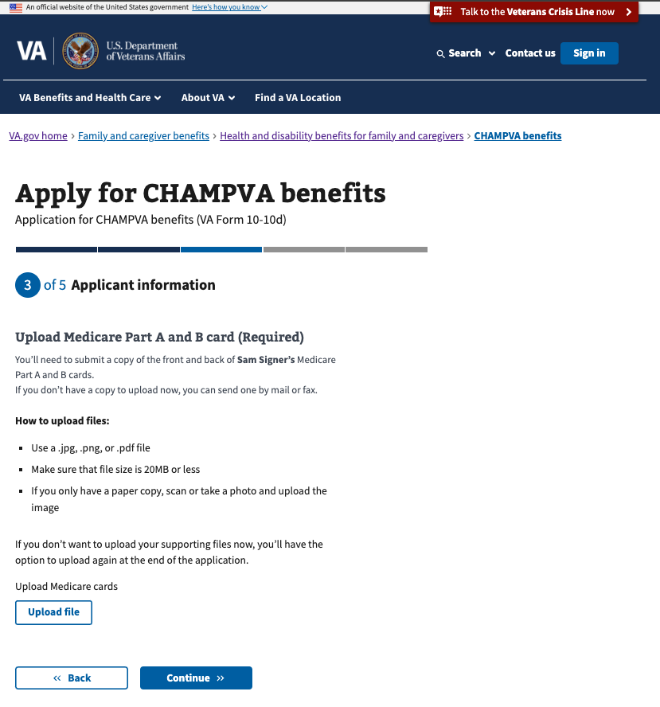

Other health insurance status

The user will be prompted to certify whether they have other health insurance, and the user will be prompted on the next screen to upload their completed form 10-7959c.  
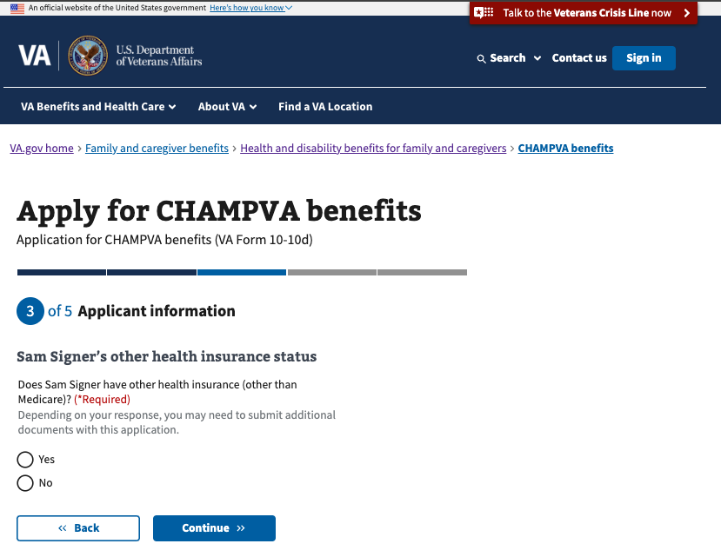

### Supporting documents upload and acknowledgement

If the user has not uploaded all documents as prompted, they’ll receive a summary of pending documents and have another opportunity to upload them.

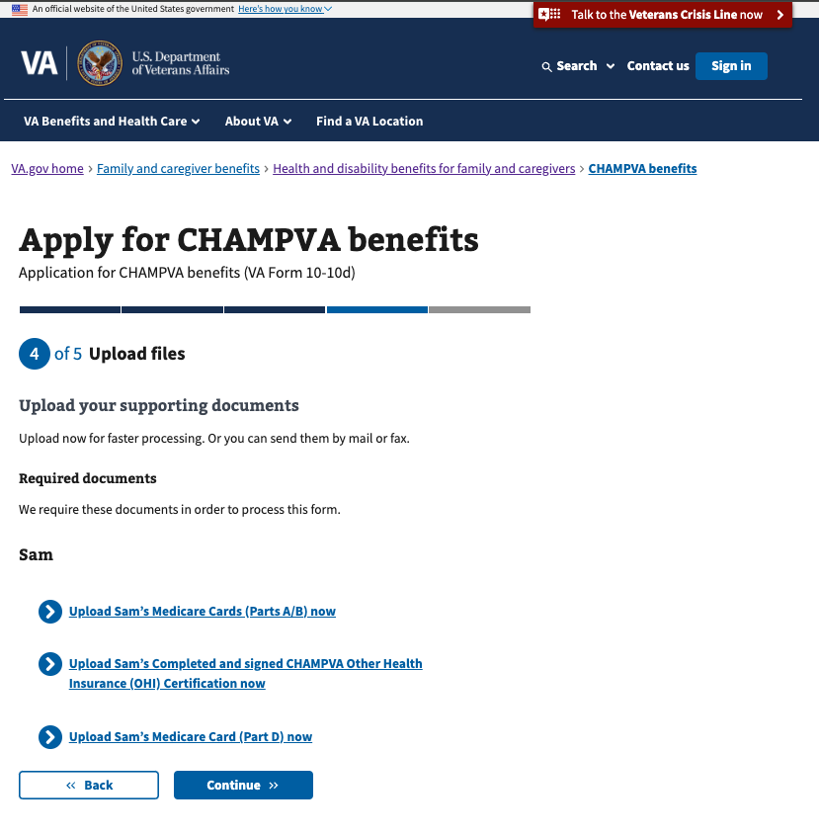

If the user chooses not to upload their documents, they’ll be asked to confirm their understanding that VA will still need this information before their application can be processed.

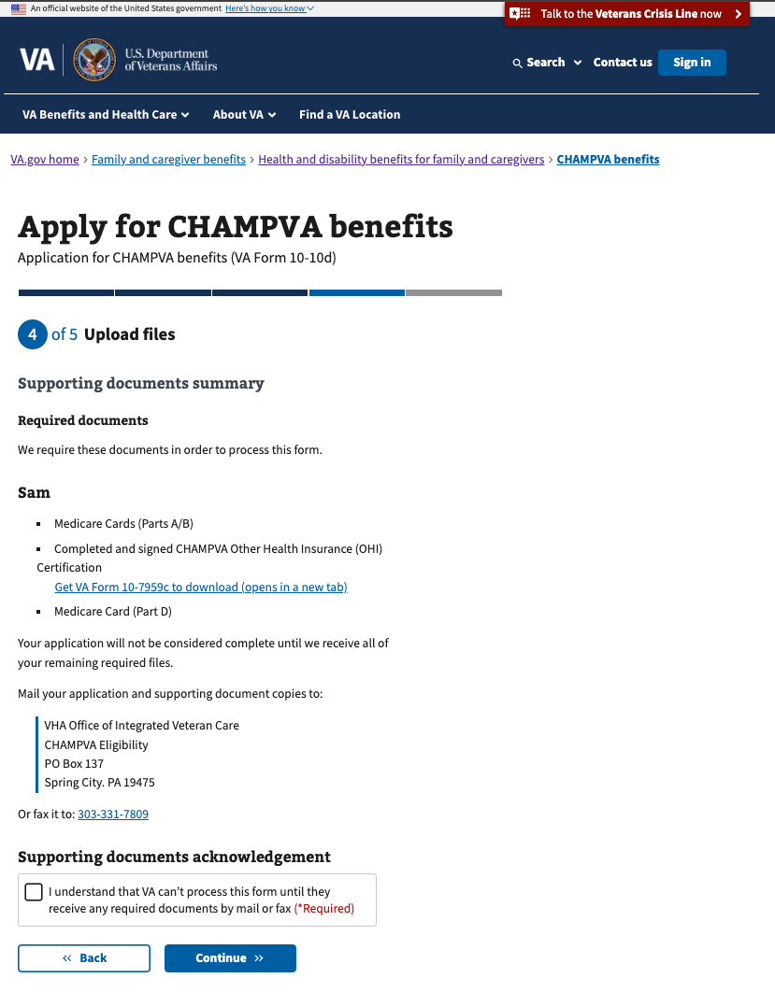

## Step 4: Review and submit

Before submitting their form, the user can review all the details of the information they entered in the previous screens. They can review each section by clicking on the plus sign to expand on the right side.

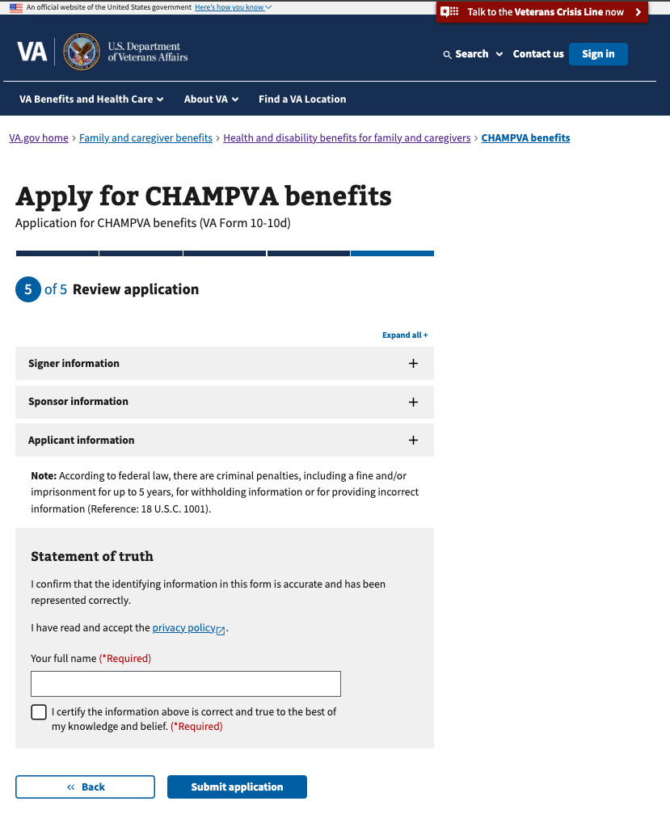

On this page of the form, the user can also confirm what documents they have uploaded with their application. In the example below, the user sees documents that have been uploaded for OHI certification.

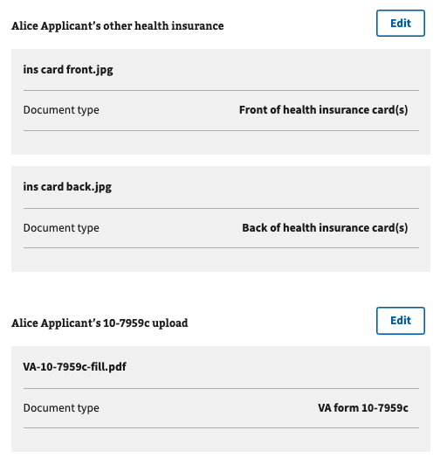

In the example below, the user sees documents that were not uploaded as part of their child’s information. In this example a birth certificate was uploaded, but additional OHI documents were not.

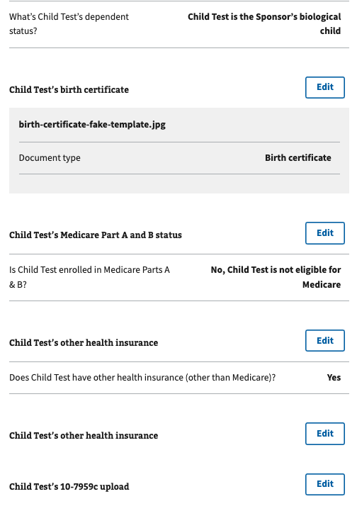

In the expanded view for each section, the user can edit their information directly in the form.

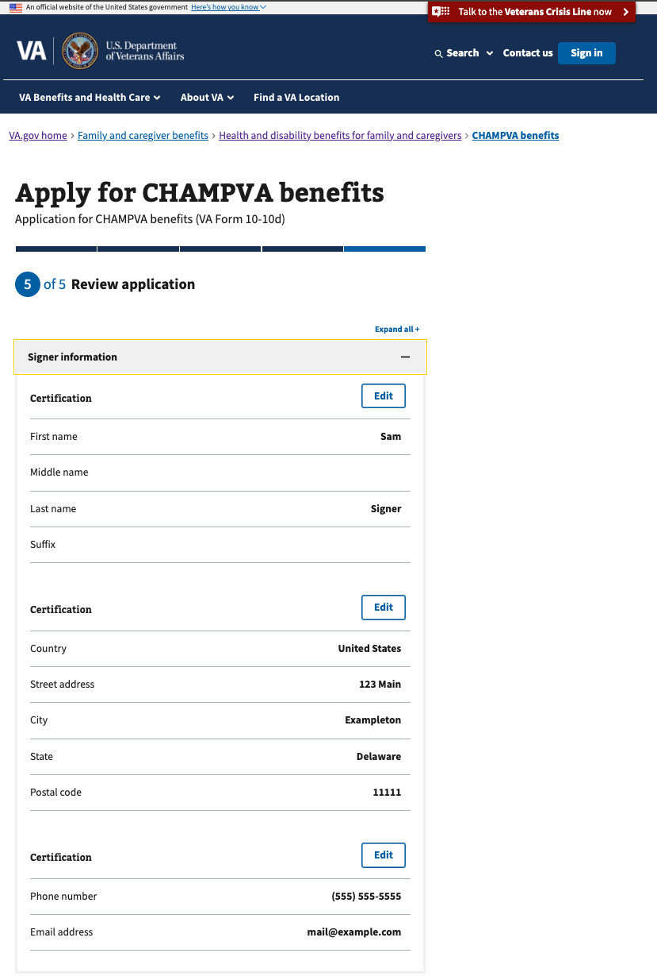

Saved progress

If the user is signed in, their progress is saved automatically, along with their responses. If they want to leave and finish the form later, they can exit by clicking on the ‘finish this application later’ link.

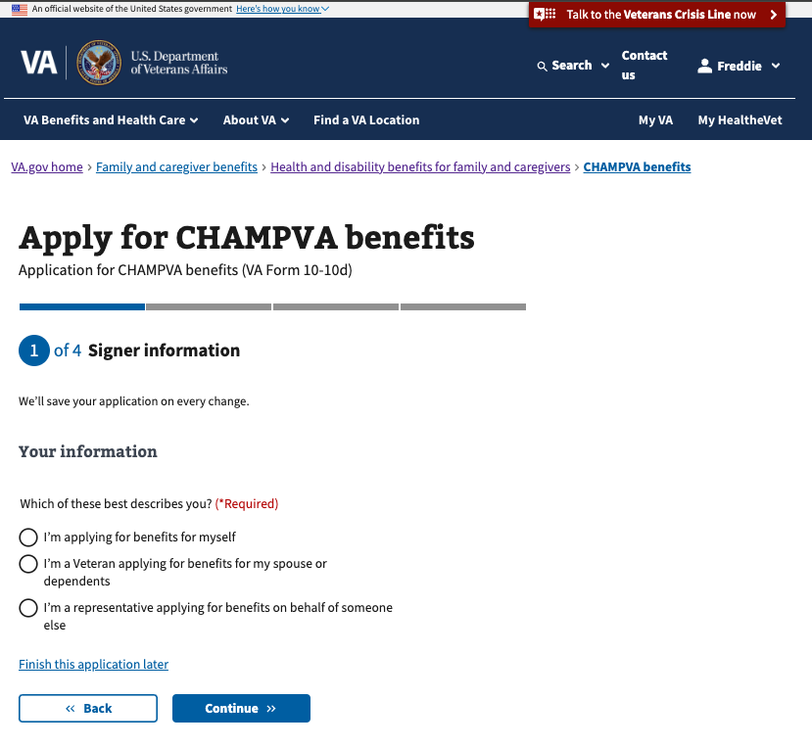

If the user is signed in, when they return to the form url, they should be able to continue the form where they left off and see their saved progress.

The user can also click to start a new application, which will clear out any previously entered responses and start the form from the beginning.

## Error messages

On the review page, if there is an issue submitting, the user will see this error message. (They will be able to try to submit again from this page).

For any connectivity issues during submission, this error message appears.

Required fields that are missing a response will appear outlined in red.

